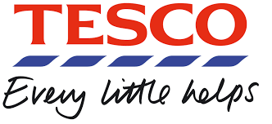

Supply Chain Management of Tesco

By: Stan Vermue, SuJeong, Raphael van den Elsen, Paul Steinheidt, and Cailyn Cochran

Shanghai University of International Business and Economics

**Table of Contents**

Abstract…………….……………………………...... 3

Tesco’s Background……………………………….... 4

Overview of Tesco’s Supply Chain…………...…….. 5

Paradigm change in Tesco’s SCM…………………... 7

SWOT Analysis of Tesco’s Supply Chain…………... 8

Conclusion…………………………………………… 11

Appendix………………………………………………12

References…………………………………..………....14

**Executive Summary**

With its global expansion, the multinational grocery and general merchandise retailer, Tesco, has experienced changes and disruptions to its supply chain over time. Packaged goods and fresh food of Tesco was produced by thousands of suppliers in more than 70 countries. Even as a large and established company, one can imagine the time and resources required to manage the flow of information and goods. Tesco originally had commercial directors in each of Tesco’s 12 markets who were responsible for sourcing and also for in-store decisions such as shelf space, pricing, and promotion. This plan had worked in the short-run to meet local preferences and keep retail prices low. Changing conditions and consumer behaviors, as well as the need to improve sales and margins to meet tougher competition, had led Tesco to create a new centralized sourcing department for food in 2010.

In this case study, we present an overview of Tesco’s supply chain, including graphics of its supply chain model. We also introduce Tesco’s long-term plan of action with Group Food, a global approach to sourcing and an end-to-end supply chain system, including forecasting and logistics, which would improve Tesco’s speed and efficiency. This case study also includes a detailed SWOT analysis of Tesco’s supply chain, in which we recognized potential risks and opportunities for Tesco.

**Tesco’s Background**

Established in 1919 Jack Cohen, founder of Tesco, began selling groceries out of a London market stall. His business model of “stack ‘em high, sell ‘em low” earned him the nickname “slasher Jack.” Not long after in 1924 the Tesco brand product, tea, was introduced and the first Tesco shop opened its doors in 1929. Over the years, expansion came through opening new and larger stores (supermarkets and hypermarketsb) as well as convenience stores, adding more categories of products, and through acquisitions. Additionally, Tesco successfully introduced innovations such as the Tesco Clubcard and the selling of financial services through Tesco Bank. (Tesco PLC)

Continuing this business strategy, Tesco had already passed its predecessors and in the mid-1990s it entered and soon conquered the international markets starting with central Europe, followed by Asia and the U.S. (Tesco PLC)

Continuous growth until 2013, which was partially due to the Group Food division established in 2010, resulted in Tesco operating in multiple store formats where it holds either the number one or number two position in eight of the 12 markets outside the UK where it operates. In addition Tesco employs 520,000 people (310,000 in the U.K.) and is the world’s largest online supermarket retailer and one of the few operating in the space that was profitable.

Seeing as the U.K. is still Tesco’s largest market, its main competitors currently are Asda, Sainsbury’s and Morison’s, which, together with Tesco, are often called the *Big Four* in the United Kingdom. (Downie)

Group sales for the fiscal year ended February 23, 2013, were £72.4 billion and included 38% from store-brand products and 4.1% from Internet sales. However since then, Tesco has experienced a significant decline in sales as well as in market share, which is partially due to an infamous accounting scandal but is currently showing signs of recovery. (Felsted)

In terms of future prospects Dave Lewis, CEO of Tesco, said: "We feel we're extremely stable and now's the time to step it up.” (The Telegraph) Tesco plans to boost the group-operating margin from 2.2% in the first half to between 3.5% and 4% by the year to February 2020. In order to boost this margin Lewis has identified $1.9 billion of savings, from distribution and logistics, improving the way it operates stores, and using its global scale to make savings. (Felsted) This indicates that Tesco acknowledges its mistakes in the past and is intending to expand and grow once more.

**Overview of Tesco’s Supply Chain**

Tesco is one of the largest and most successful retailers worldwide, spreading from Europe to Asia. (Where Tesco Went Wrong With Its Suppliers, 2015) In the beginning of 2017 Tesco had nearly 7000 stores. (Analyzing The Case Study Of Tesco Supply Chain Logistics Business Essay, 2015) All these stores need to be provided with products. This signifies how important the supply chain is for Tesco. Products must be shipped from suppliers to stores worldwide.

Tesco’s vision was to become the ‘’new Toyota’’ of grocery business, by creating a prosperous supply chain with the constant transportation of goods along the chain.

Tesco has been expanding since 1948, while the supply chain developed and expanded over time. For example: During the 1950’s, Tesco’s model was to ‘’pile it high and sell it cheap’’. (chouhan, 2014)

Since then, Tesco started to focus more on superstores. Their supply chain covers supplying an array of Tesco’s brick and mortars, ranging from kiosks to hyper malls.

During the 1980s Tesco used 26 depots to supply to all of its retail stores. These were relatively small and inefficient. The amount that was transported to each store was low, compared to the quantities that are transported nowadays. Products that needed to be transported under certain temperatures were transported in separate vehicles. Tesco needed to change its distribution system, because the volumes were getter bigger and the temperature control standards were increasing. (Strategic supply chain management, 2014)

Tesco improved its depots drastically by making them more efficient and cost-effective. Furthermore, they improved their daily delivery service to all of its retail stores. All the non-food products were transported separately. (Strategic supply chain management, 2014)

These days Tesco tries to order only what is needed for the following day. The aim is not to stock fast moving products in a depot at all. Some spaces in the depots can be used several times over. (Strategic supply chain management, 2014)

Tesco uses cross docking to supply to its supermarkets. Inbound goods are immediately taken from the receipt location to a staging location for issue. In this process there are no intermediate storages. This process is shown in the image bellow. (Chouhan, 2014)

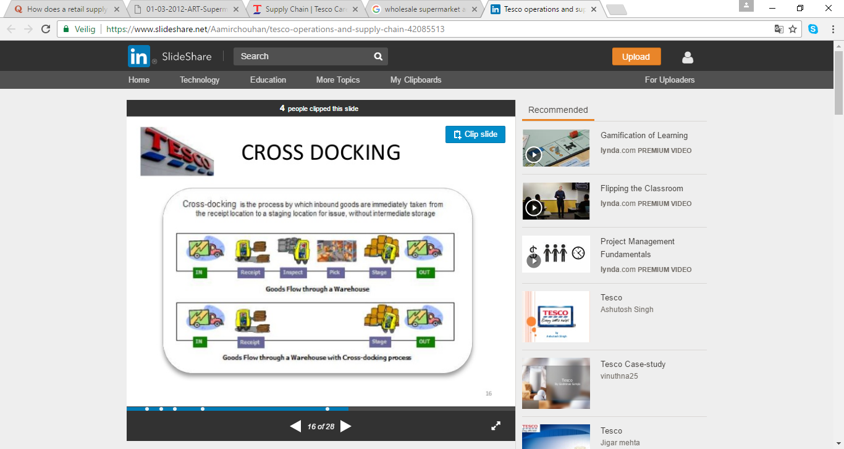

Tesco continuously replenishes its products. This continuous replenishment is triggered by customer demand. (chouhan, 2014)

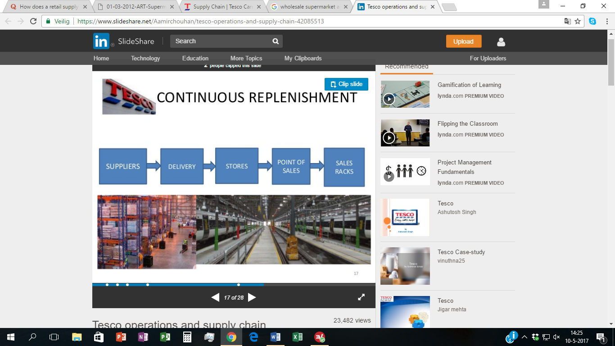

A case study of Thomas in 2010 found that Tesco’s product range has been growing rapidly in the last few years. Tesco has been broadening its product-range from food to electrical goods, stationary, clothing and others. This is supported by several thousands of suppliers. In one year around 2.1 billion cases of products are shipped from suppliers to Tesco’s stores. (Strategic supply chain management, 2014)

One of the most crucial elements in an efficient supply chain is the mode of transportation. When it comes to transporting their products, Tesco monitors the carbon emission produced during distribution of goods. Their logistics is based on having a sustainable distribution network. (T PLC, Our carbon footprint) Paragon, a company involved in logistics, works together with Tesco. Paragon works with Tesco to keep their supply chain efficient on both mileage and emission. An example of this is that some of Tesco’s products are delivered by a battery powered truck.

Tesco also has a home shopping service. Tesco held a competitive advantage by being the first food retailer to get a profit out of online shopping since 2006.

Another significant factor in Tesco’s supply chain is that Tesco is known for using sophisticated data mining on their supply chain. Using these analytics not only saved the company millions of pounds, it also helped Tesco to spot new opportunities, optimize promotions and optimize stock efficiency to demand. (Tesco saves millions with supply chain analytics, 2013) The analytics are even so sophisticated that it can accurately predict the impact of the weather on the buying behavior of Tesco’s customers with a model. Tesco has a specialized team for this, which consists of 50 employees. Accurate forecasts also helped Tesco to reduce their waste. Tesco is now leading in reducing its food waste. (Jose B. Alvares, 2014)

Today, every country in which Tesco is active has its own centralized forecast system.

In 2003 Tesco used RFID technology on trial basis. This gave Tesco a few advantages compared to their competitors. First of all, the could easily track their products. Secondly, Tesco was able to provide its products with unique identification and security. Moreover, RFID technology helped Tesco in measuring and controlling all of the aspect its supply chain. Finally, RFID technology made processing goods more efficient regarding employees and costs. (chouhan, 2014)

Another technologycal system Tesco uses is called the EPOS (electronic point of sales) system. This system enables Tesco to keep track of when they have to send new products to the individual retail stores. When products are scanned to be sold they are immediately recorded to be out of stock.

Tesco continuously switches suppliers to get the best prices available on the market. This, however, led to poor relationships between Tesco and its suppliers, meanwhile fragmenting its supply chain.

Recently, Tesco tried to optimize supply chain of their meat and fish. Instead of buying ready-to-go products and selling them directly, Tesco decided to buy the meat or fish, bring it to their supplier and let them cut it up and pack it. (Jose B. Alvares, 2014)

Another change in the supply chains towards Tesco’s suppliers is that Tesco tried to get closer to the supply base of their products. Consumer expectations about food have been changing. Consumers like to have safer, more adequate and more sustainable products. Tesco wanted to ensure this by having on-the-ground presence at sourcing hubs. This allowed them to get a better assessment of the products’ quality. (Jose B. Alvares, 2014)

Tesco’s supply chain is also heavily influenced by the fact that Tesco is active in so many different countries. An average Tesco supermarket has more than 40.000 stock-keeping units, of which a lot depend on local taste. Also, Tesco gets some of its products at local suppliers.

An efficient and effective supply chain is essential for keeping Tesco’s business healthy. Tesco became successful by having a well-functioning distribution network. Tesco is different from its competitors by having innovative advantage in their supply chain. Tesco actively uses analytics for their supply chain. Furthermore, Tesco aims for constant improvement in their supply chain, by trying to offer the best quality and cheapest products. Lastly, Tesco’s supply chain is characterized by lowering the carbon footprint of the transportation of goods.

**Paradigm change in Tesco’s supply chain management**

As mentioned before, Tesco’s country-based teams play a major role in the supply chain management of the company. Formerly Tesco made use of the “Non direct model” otherwise referred as the traditional model which wasn’t up to standard. In response Tesco introduced the new Group food structure in which the key concept was to split buying from selling while still making sure that consumer needs were met. Under this new model, Tesco’s country-based buying teams would delegate their responsibility for purchasing most store-brand food and grocery products to the Group Food team. This allowed the country teams to allocate more time to product development and innovation while Group Food teams developed deeper sourcing expertise in each category. Group Food’s role was to identify suppliers, develop relationships, negotiate contracts and prices, remove middlemen that added no value, and work as deep in the supply chain as possible. (B. Alvarez, Mcloughlin, & Shelman)

According to Jose Alvarez, from Harvard business school, the Group Food removed the middlemen but did not eliminate all importers because they performed an important coordination and consolidation function. But wherever possible, the number of firms was reduced and Tesco paid them for their services rather than buying products from them. (See Appendix 9 for an example.) For meats and processed products, Group Food changed from buying finished products through tenders to long-term contracts and an open book model and provided help sourcing key ingredients. The key elements of Group Food’s approach included: introducing buying specialists, leveraging scale, partnering with suppliers, applying sourcing skill, and end-to-end supply/demand planning. (B. Alvarez, Mcloughlin, & Shelman)

**Analysis of Tesco’s supply chain**

Like most companies today, Tesco found that consumers are “under economic pressure to buy cheaper food, yet they are also increasingly concerned about its safety, where it came from, and how it was produced”(Alvarez, McLoughlin, Shelman, 2014). With the rise of technology, customers are shopping on multiple channels and have access to information more quickly. With customers in mind, competitors of Tesco have pushed them to improve sale ands margins to match competition. In 2010, Matt Simister led the new Group Food division. The job of the Group Food is to develop a global approach to sourcing and an end-to-end supply chain system, including forecasting and logistics, which would improve Tesco’s speed and efficiency. In the following part, we will analyze the strengths, weaknesses, opportunities, and threats of Tesco’s business model and of the supply chain management.

One of the most important steps to improve the Supply Chain of Tesco was to modify the purchasing system. As mentioned earlier, Tesco’s food sourcing was run by twelve separate country commercial buying teams that both sourced and merchandised the products. Even though each was in charge of a separate countries market, they still bought from the same supplier, but the supplier negotiated different prices with each market. To build up and to establish an end-to-end supply chain system, which allows Tesco to be faster and more efficient, the company grounded the new centralized procurement division “Group Food” in 2010. The key elements of this strategy were to introduce buying specialists, to use leverage scale, to improve partnerships with suppliers, to apply sourcing skills, and to establish an end-to-end supply/demand planning.

With the Group Food being established in 2010, Matt Simister was challenged to build a central sourcing team for a diverse set of products ranging from fresh produce, meat, and seafood to store brand soups, biscuits, and toilet paper. Tesco also faced the problem of its intense focus on operational efficiency that encouraged supply chains to wait until the very last minute to finalize orders. Siobhan Harrison commented the following about Tesco’s supply chain: “We didn’t provide forecasts and changed our orders at very short notice. As a result, there was no ability for our suppliers or us to drive efficiency in the supply chain.” To establish a centralized procurement system Tesco hired external procurement specialists for certain commodities. With their knowledge about the commodities and the suppliers Tesco could save a lot of money in the following years.

Another important point was that through the considerably larger order quantity higher discount rates could be used and fixed costs could be minimized so that the leverage scale increased as well. Furthermore, it was important to improve the supplier relationships. Therefore, Tesco started to work with fewer but larger suppliers on a long-term level. Together they established an open book policy so that a mind and knowledge exchange could take place and the collaboration could be improved. To make sure that the products satisfy the customer requirements Tesco also helped to find the right farmers and raw material suppliers. As a result, the knowledge about the supply chain and the products could grow and the planning process could be simplified. Further savings and a greater efficiency could also be achieved by introducing a new demand-supply forecast system.

**Strengths**

Nowadays Tesco has distributed around 30 million club cards to customers worldwide. With the saved information, Tesco is able to notice changes in customers' buying behavior and react on them in time. Also Tesco has placed demand planners in each country who generate quite exact forecasts. These forecasts are compared with the quantities in the stores, warehouses and distribution centers so that the supply and demand management has been improved and the waste could be reduced. All in all this strategy has already saved millions of dollars.

(Jose B. Alvares, 2014) (Where Tesco Went Wrong With Its Suppliers, 2015)

Another strength of Tesco is that the company constantly improves their supply chain and uses innovative techniques. For example Tesco uses a transport system, which is monitoring the emission production during the transport. This environmentally conscious system also represents the new requirements of many customers so that it affects the image in a positive way.

(Jose B. Alvares, 2014)

**Weaknesses**

One of the biggest weaknesses of Tesco is that the business performance of the company is still depending on the UK market. Tesco generates more than 70% of the total revenue on this market so that a risk allocation is not given. Because the working environment and the price war with other supermarkets like Lidl and Aldi became fiercer in the last years Tesco had to accept high sales and profit declines. Furthermore, it can’t be predicted which consequences the Brexit will have for the company.

Tesco is active in market environments where the competition is very high and where the company has to react quickly on new customer requirements or new market conditions (for example new order techniques). These threats can influence the market position of a company in both directions depending on how well and flexible a company can adapt.to the new situation. Especially on the online channel Tesco works very efficient. The company was the first retailer in the UK which successfully implement an online sales channel and generated high revenues.

Because Tesco is a company with global structures it is also a big chance for Tesco to expand their business in foreign markets or to expand their product range. But these chances are also depending on the behaviour of the market competitors.

In addition to Tesco’s expansion from brick and mortar to online retailing, it must be aware of potential security threats. Consumer’s information must be protected against hackers and malicious online sources.

**Opportunities**

With the rise of ecommerce, Tesco has the ability to reach an exponential amount of consumers. This opportunity allows Tesco to gain more exposure globally. Along with ecommerce advantage, there is significant opportunity to grow online shopping for TESCO as well as offer its home delivery service to more areas.

In countries where Tesco may be underperforming, there could be opportunities for joint ventures in which the local company can help with market research and target marketing to improve performance in those areas.

**Threats**

In today’s market, the flow of information to consumers is rapid. Consumers are able to obtain most information within a few clicks of their mouse. This may come as a threat to companies, such as Tesco, who feels pressured to make business operations transparent. Consumers want to know where their food comes from, how it is handled and even disposed. This also threatens large companies, like Tesco, because they stay on top of their suppliers to stay accountable for providing safe goods.

Another threat for Tesco is competition. As an established company, Tesco may assume they are guaranteed safety against new competition. Tesco continues to resist the takeover of Asda by Wal-Mart. The brand of Asda by Wal-Mart has been increasing in the UK. The ninth most-valued brand in the world, Wal-Mart is Tesco’s largest global competitor and therefore has the necessary skills, resources, experience and funds to cause Tesco problems (Brand Finance, 2014). The effect of town planning and consumer intolerance for out-of-town stores, as well as concern for the livelihood of small shops, can also imperil Tesco’s expansion plans (Stevenson, 2014).

Recommendation

In order to order to guarantee the safety of products for customers, we recommend Tesco to give full transparency on their supply chain. This includes all of the supplier and distributor information and a complete geographical location of their suppliers.

Next, we recommend that Tesco recognizes all opportunities to enter markets that its competition, as Wal-Mart, has struggles to obtain. In order to do this Tesco should combine its consumer research with their local market consumer research to optimize their ability to succeed in gaining entry into the hard to reach markets.

Consumer wants the quickest easiest way to obtain their goods. They generally do not want a long thought process when it comes to purchasing online. We recommend that Tesco uses its recourses to guarantee the customers’ online satisfaction. This implies that Tesco offers quick and secure services to online consumers. With the growth of ecommerce Tesco should is able to cater to each audience in markets all of the world.

As recognized is the weaknesses 70% of Tesco’s revenue is still based out of the UK. In order to stay on top of its competitors, Aldi and Lidl, we recommend that Tesco puts more effort towards its global stores and consumers.

**Conclusion**

Like most established companies, Tesco’s supply chain has experienced drastic changes to ensure its efficiency and sustainability. With its changes, their vision to sell goods at the lowest price remains constant. Through data analysis, they are able to meet their customers’ needs and demands.

In relation to its supply chain, they do not hesitate to use new technology and introduce new systems to effectively manage their SCM. In particular, they focus on their relationship with tier suppliers. Through such skills, the integration of supply chain management networks across the world allows for communication processes to be shared quickly and easily.

**Appendix**

Traditional Approach

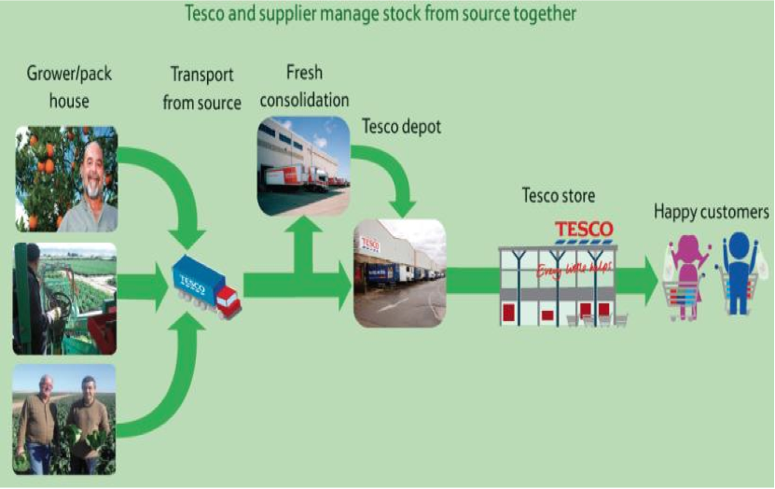

Group Food Approach

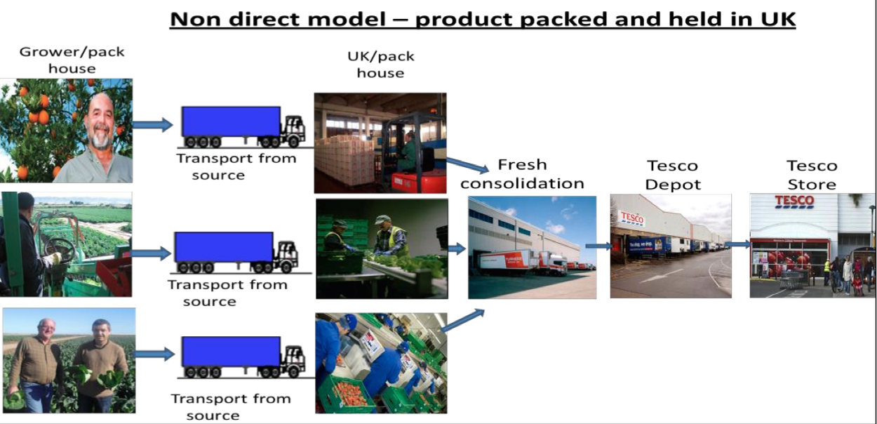

Tesco Net Revenue in Billion Pound

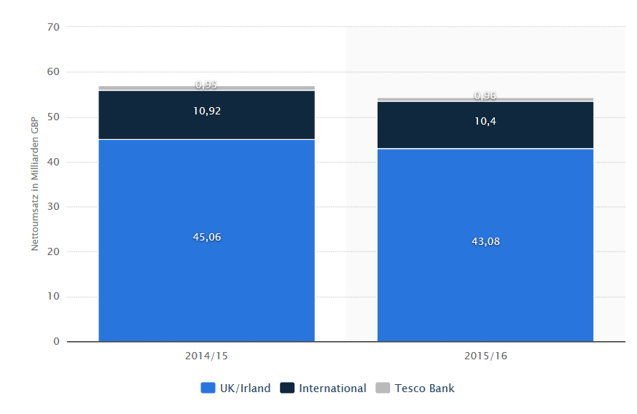

**References**

Ahmed, K. (2015, January 19). Tesco: Where it went wrong. Retrieved May 10, 2017, from <http://www.bbc.com/news/business-30886632#share-tools>

Alle Preise verstehen sich zzgl. der gesetzlichen MwSt.Mindestlaufzeit 12 Monate. (n.d.). Umsatz von Tesco weltweit nach Regionen bis 2015/16 | Statistik. Retrieved May 10, 2017, from https://de.statista.com/statistik/daten/studie/155272/umfrage/tesco-plc-%25E2%2580%2593-umsatz-der-gruppe-nach-regionen/

Alvarez, J. B., McLoughlin, D. P., & Shelman, M. (2014, January 16). Tesco Group Food. Retrieved May 11, 2017, from https://hbr.org/product/Tesco-Group-Food/an/514022-PDF-ENG

Brand Finance (2014). Global 500 2014: The world’s most valuable brands. Available at: <http://brandirectory.com/league_tables/table/global-500-2014> [accessed 1 September 2014].

Chouhan, A. (2014, November 23). Tesco operations and supply chain. Retrieved from https://www.slideshare.net/Aamirchouhan/tesco-operations-and-supply-chain-42085513

Essays, UK. (November 2013). Analyzing The Case Study Of Tesco Supply Chain <https://www.ukessays.com/essays/business/analyzing-the-case-study-of-tesco-supply-chain-logistics-business-essay.php?cref=1>

Essays, UK. (November 2013). Analyzing The Case Study Of Tesco Supply Chain Logistics Business Essay. Retrieved from https://www.ukessays.com essays/business/analyzing-the-case-study-of-tesco-supply-chain-logistics-business-essay.php?cref=1

PLC, T. (n.d.). Our carbon footprint. Retrieved May 10, 2017, from <https://www.tescoplc.com/tesco-and-society/sourcing-great-products/reducing-our-impact-on-the-environment/our-carbon-footprint/>

Ruddick, G. (2013, September 28). Tesco fights to refind its form. Retrieved May 10, 2017, from <http://www.telegraph.co.uk/finance/newsbysector/retailandconsumer/10341790/Tesco-fights-to-refind-its-form.html>

Stevenson, T. (2014). Tesco share slide has investors catching a falling knife. Daily Telegraph, 29th August 2014.

Strategic supply chain management. (2014, November 3). Retrieved May 10, 2017, from https://www.aba-procurement.com/wp-content/.../PD3-Nov-2014-Case-Study.pdf

SWOT Analysis of TESCO Group. (n.d.). Retrieved May 10, 2017, from http://www.businessteacher.org.uk/guides/business/swot/swot-analysis-of-tesco.php

https://www.aba-procurement.com/wp-content/.../PD3-Nov-2014-Case-Study.pdf

Tesco saves millions with supply chain analytics. (2013, April 16). Retrieved May 10, 2017, from http://www.information-age.com/nordea-prepares-for-wave-of-regulation-with-new-data-warehouse-123456967/